JENNA BAYLEY-BURKE
Media Kit

Photo
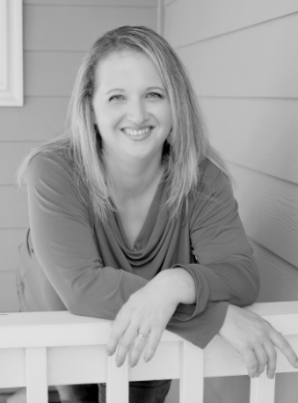
About
Jenna Bayley-Burke believes in falling in love, one story at a time. Be that in books, movies, or your honey’s stand-up routine.

She tells fantasies of billionaires and beautiful locations, cowboys and fake engagements, women we all want as friends and men that we hope ours act like on occasion.

Jenna is available for speaking engagements, workshops, interviews, and appearances. She loves to chat with book clubs and writing groups, in person or through video chat.
Contact info
WWW.JENNABAYLEYBURKE.COM
JBAYLEYBURKE@GMAIL.COM

1.8K 1K 100 500 200

Social Media
Facebook: http://bit.ly/2kDK5XE
Pinterest: http://bit.ly/2kDJZPM
Goodreads: http://bit.ly/2giBWWp
Blog: http://jennabayley-burke.blogspot.com/
Tumblr: http://jennabayleyburke.tumblr.com/
G+: http://bit.ly/2kDTLSd
Instagram: http://bit.ly/2jkZO0K
Newsletter: http://bit.ly/2kJRX98

Workshops
- Writing is an Analytical Sport
- Writing to Deadline: finish a book in 30 days or less
- Targeting Category Romance
- Nuts & Bolts: Writing today’s romance heroes from the inside out
- The Mommy’s Guide to Writing Around Kids
- Short & To The Point: stories & novellas
- Salvaging Your Rejected Manuscript
- NaNoWriMo 101
- Romance 101

Press
USA Today: http://usat.ly/2khK8KW
Better Homes & Gardens: http://bit.ly/2kJGq9Z
Good Morning America: http://abcn.ws/2k7uGPq
Library Journal: http://bit.ly/2kiipu3

